**Date:** 25th August, 2025

**Program Title:** Tic-Tac-Toe

**Observation:**

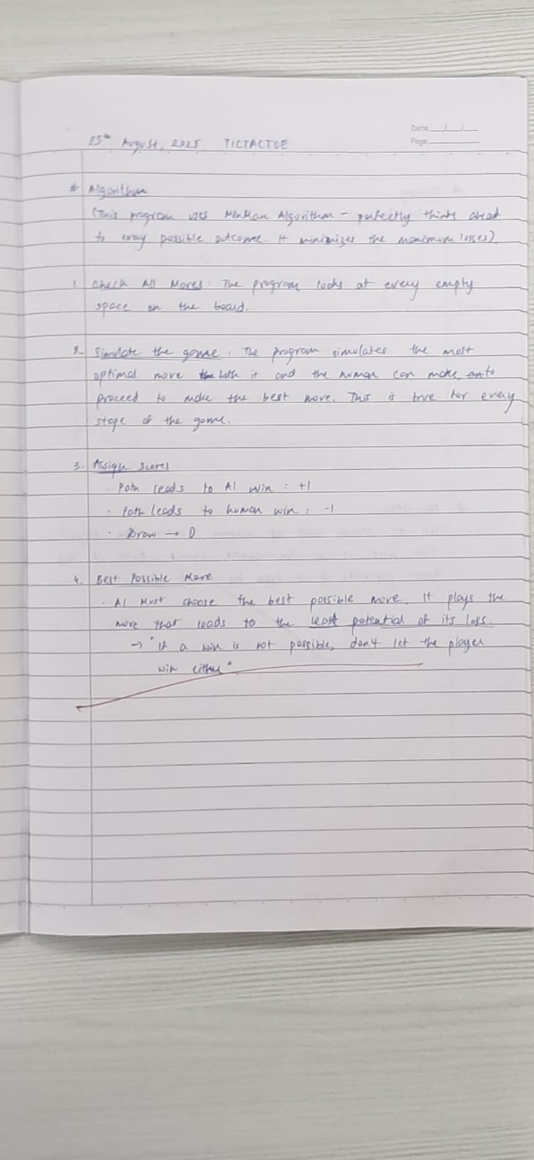

**Syntax:**

**board={1:' ',2:' ',3:' ',**

**4:' ',5:' ',6:' ',**

**7:' ',8:' ',9:' '**

**}**

**def printBoard(board):**

**print(board[1]+'|'+board[2]+'|'+board[3])**

**print('-+-+-')**

**print(board[4] + '|' + board[5] + '|' + board[6])**

**print('-+-+-')**

**print(board[7] + '|' + board[8] + '|' + board[9])**

**print('\n')**

**def spaceFree(pos):**

**if(board[pos]==' '):**

**return True**

**else:**

**return False**

**def checkWin():**

**if(board[1]==board[2] and board[1]==board[3] and board[1]!=' '):**

**return True**

**elif(board[4]==board[5] and board[4]==board[6] and board[4]!=' '):**

**return True**

**elif(board[7]==board[8] and board[7]==board[9] and board[7]!=' '):**

**return True**

**elif (board[1] == board[5] and board[1] == board[9] and board[1] != ' '):**

**return True**

**elif (board[3] == board[5] and board[3] == board[7] and board[3] != ' '):**

**return True**

**elif (board[1] == board[4] and board[1] == board[7] and board[1] != ' '):**

**return True**

**elif (board[2] == board[5] and board[2] == board[8] and board[2] != ' '):**

**return True**

**elif (board[3] == board[6] and board[3] == board[9] and board[3] != ' '):**

**return True**

**else:**

**return False**

**def checkMoveForWin(move):**

**if (board[1]==board[2] and board[1]==board[3] and board[1] ==move):**

**return True**

**elif (board[4]==board[5] and board[4]==board[6] and board[4] ==move):**

**return True**

**elif (board[7]==board[8] and board[7]==board[9] and board[7] ==move):**

**return True**

**elif (board[1]==board[5] and board[1]==board[9] and board[1] ==move):**

**return True**

**elif (board[3]==board[5] and board[3]==board[7] and board[3] ==move):**

**return True**

**elif (board[1]==board[4] and board[1]==board[7] and board[1] ==move):**

**return True**

**elif (board[2]==board[5] and board[2]==board[8] and board[2] ==move):**

**return True**

**elif (board[3]==board[6] and board[3]==board[9] and board[3] ==move):**

**return True**

**else:**

**return False**

**def checkDraw():**

**for key in board.keys():**

**if (board[key]==' '):**

**return False**

**return True**

**def insertLetter(letter, position):**

**if (spaceFree(position)):**

**board[position] = letter**

**printBoard(board)**

**if (checkDraw()):**

**print('Draw!')**

**elif (checkWin()):**

**if (letter == 'X'):**

**print('Bot wins!')**

**else:**

**print('You win!')**

**return**

**else:**

**print('Position taken, please pick a different position.')**

**position = int(input('Enter new position: '))**

**insertLetter(letter, position)**

**return**

**player = 'O'**

**bot ='X'**

**def playerMove():**

**position=int(input('Enter position for O:'))**

**insertLetter(player, position)**

**return**

**def compMove():**

**bestScore=-1000**

**bestMove=0**

**for key in board.keys():**

**if (board[key]==' '):**

**board[key]=bot**

**score = minimax(board, False)**

**board[key] = ' '**

**if (score > bestScore):**

**bestScore = score**

**bestMove = key**

**insertLetter(bot, bestMove)**

**return**

**def minimax(board, isMaximizing):**

**if (checkMoveForWin(bot)):**

**return 1**

**elif (checkMoveForWin(player)):**

**return -1**

**elif (checkDraw()):**

**return 0**

**if isMaximizing:**

**bestScore = -1000**

**for key in board.keys():**

**if board[key] == ' ':**

**board[key] = bot**

**score = minimax(board, False)**

**board[key] = ' '**

**if (score > bestScore):**

**bestScore = score**

**return bestScore**

**else:**

**bestScore = 1000**

**for key in board.keys():**

**if board[key] == ' ':**

**board[key] = player**

**score = minimax(board, True)**

**board[key] = ' '**

**if (score < bestScore):**

**bestScore = score**

**return bestScore**

**while not checkWin():**

**compMove()**

**playerMove()**

**Output:**

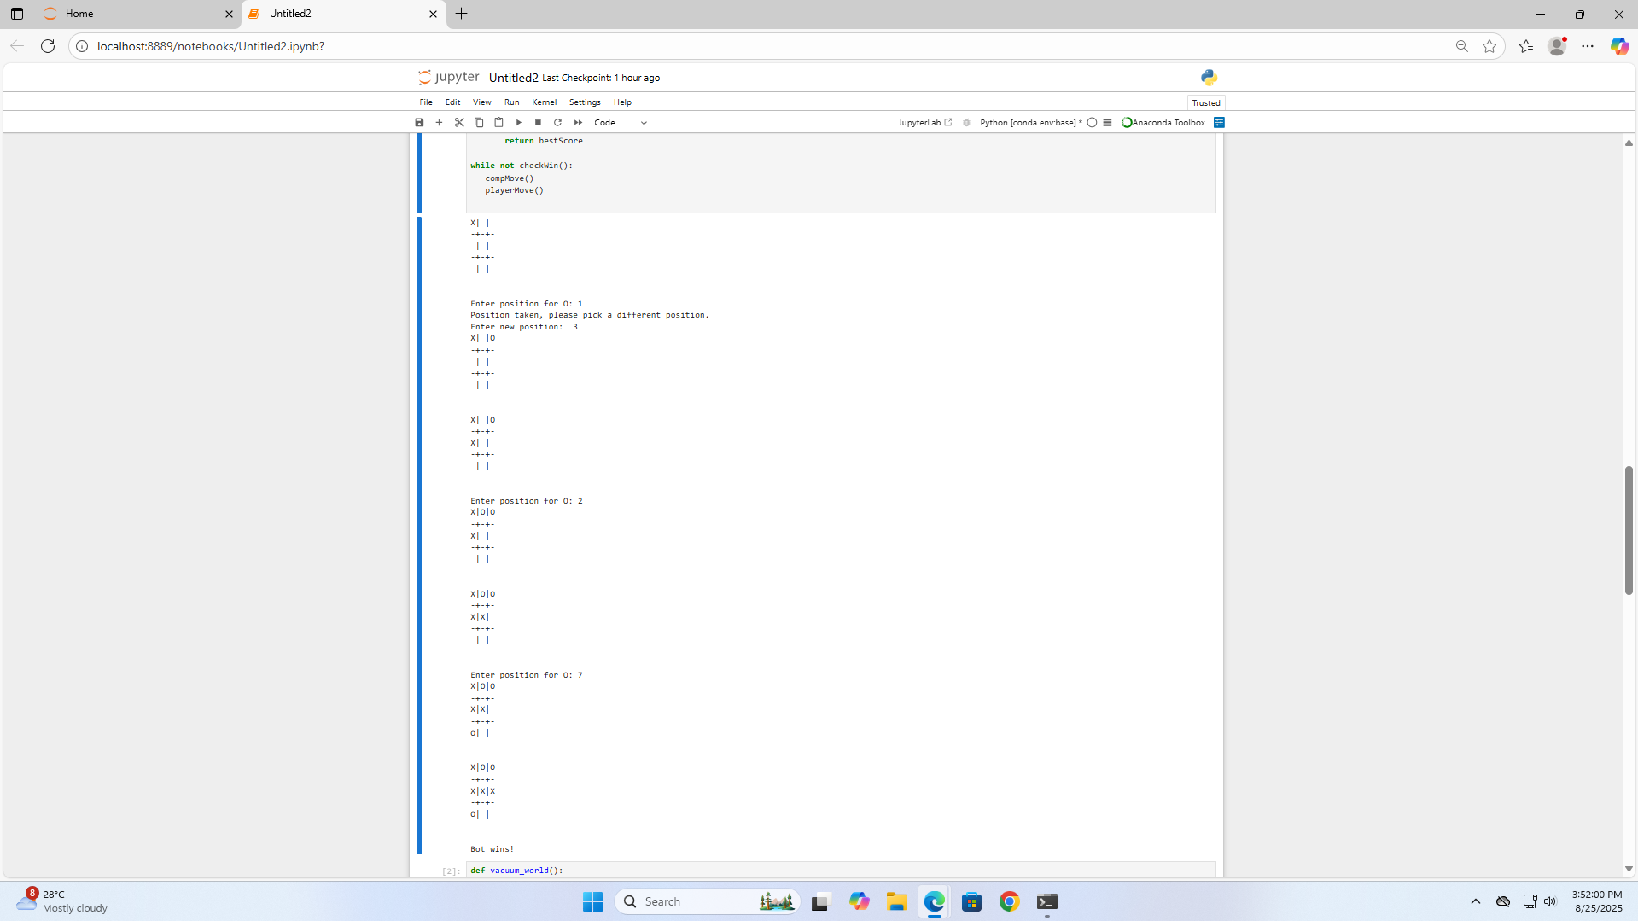

**Tracing:**

